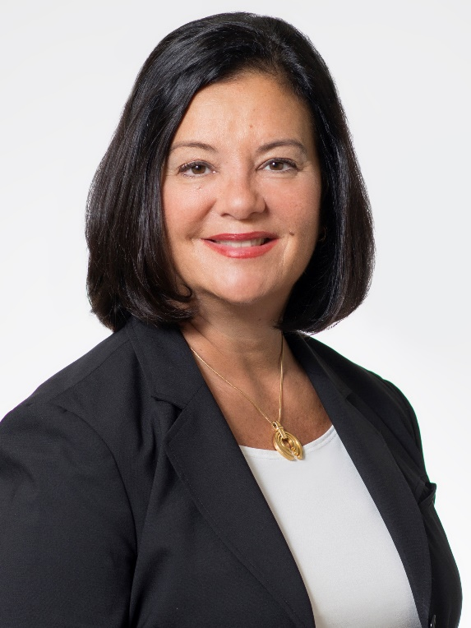

Dr. Marie Bountrogianni
Dean, The G. Raymond Chang School of Continuing Education

Dr. Marie Bountrogianni is Dean of The G. Raymond Chang School of Continuing Education at Ryerson University in Toronto, Ontario. Prior to joining Ryerson, she was president and executive director of the ROM Board of Governors.
As a former Ontario cabinet minister, Dr. Bountrogianni served as minister of a number of portfolios including Intergovernmental Affairs, Democratic Renewal, Children and Youth Services, and Citizenship and Immigration. During her time in office, she was instrumental in negotiating a number of landmark federal-provincial agreements and in authoring the Accessibility for Ontarians with Disabilities Act (AODA), which established Ontario as a world leader in accessibility.
Prior to entering politics, Dr. Bountrogianni was the chief psychologist for the Hamilton Wentworth District School Board. Marie has taught at Seneca College, McMaster University and Wilfrid Laurier University. She holds a doctorate in Applied Psychology from the University of Toronto. She is a board member of Northland Power Inc., Skills Connect Inc. and the Human Resources Policy Committee of the Canadian Chamber of Commerce. In 2014, the CBC named Marie as one of the top 10 most influential alumni at the University of Waterloo and in 2015, she was further recognized by Her Campus Waterloo as one of five influential women who have graduated from the University of Waterloo.

Updated January 13, 2016

